

***LAB REPORT 9***

***Muhammad Rafay***

***20P-0018***

***Computer Networks***

***Sec A***

**Setting a wireless connection.**

**TASk 1:**

**Topology.**

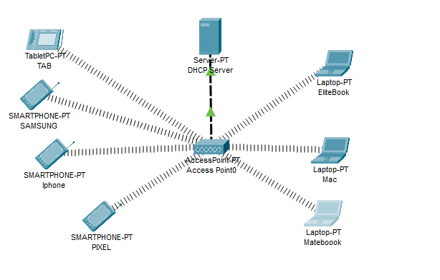

**Laptops interface Card Change.**

At first we are changing the interface card of our laptop from ethernet to wireless card .

Here we are using WPC300N.

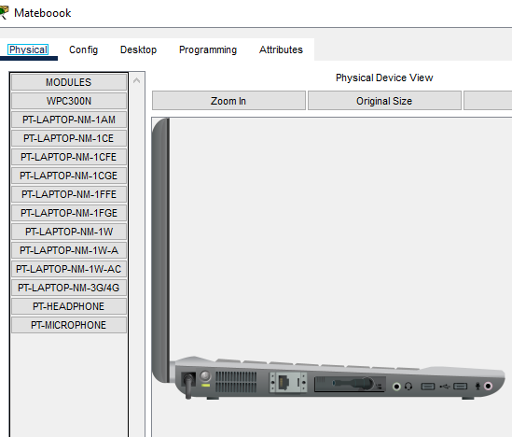

**DHCP Server.**

After setting up our laptop and other devices we are configuring our DHCP server and creating a Pool for our local area wireless network.

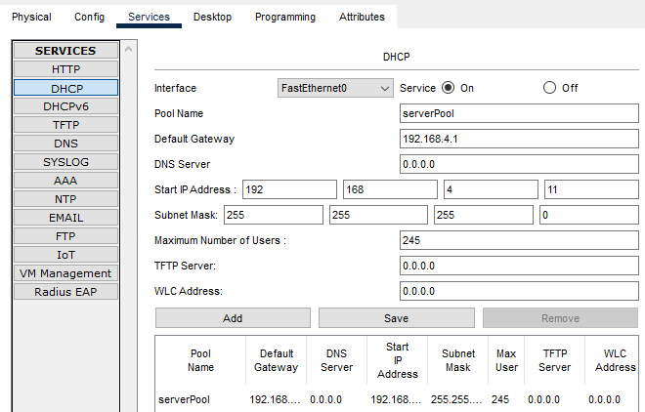

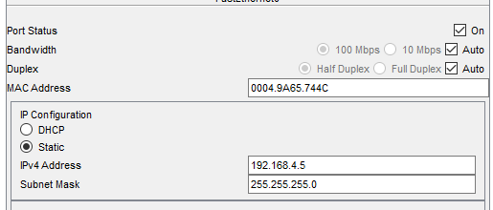

**DHCP IP’s to our Devices.**

At last we are assigning ips to our devices using DHCP.

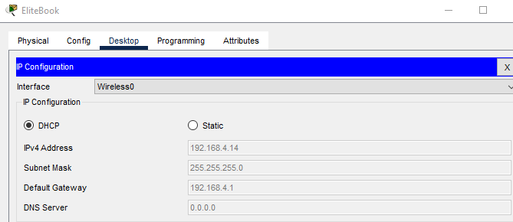

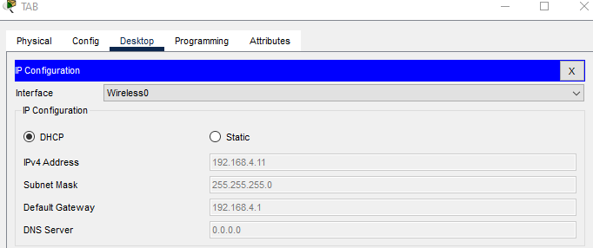

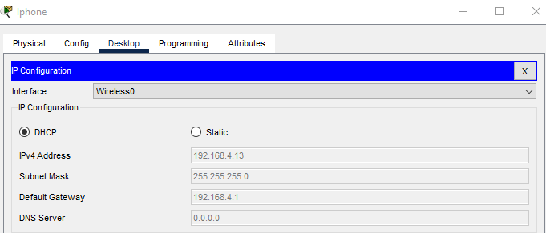

**TASK 2.**

**TOPOLOGY.**

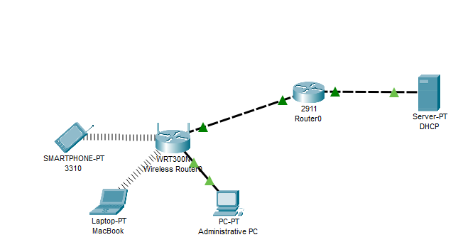

**Laptop Interface Card Change.**

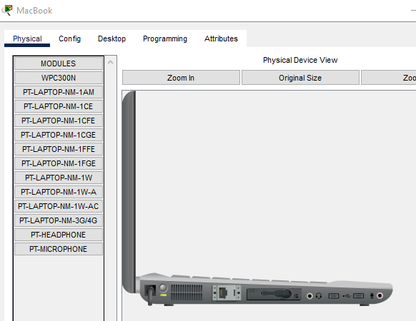

**Configuring Administrative PC .**

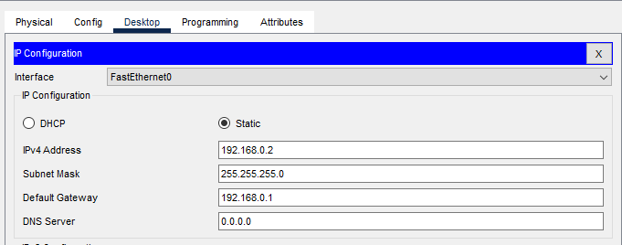

**Configuring Wireless Router.**

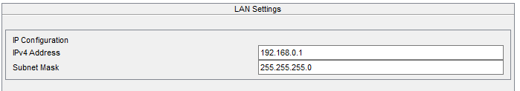

**Logging in to wireless router’s GUI TAB using administrative PC.**

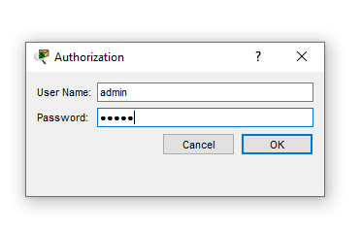

**Password Update.**

Updating wireless router’s password .

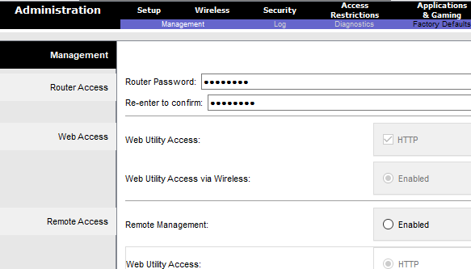

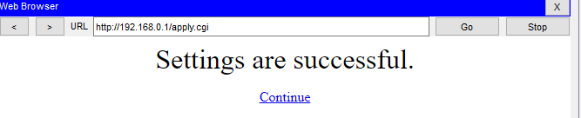

**DHCP Setting From Wireless Router’s GUI.**

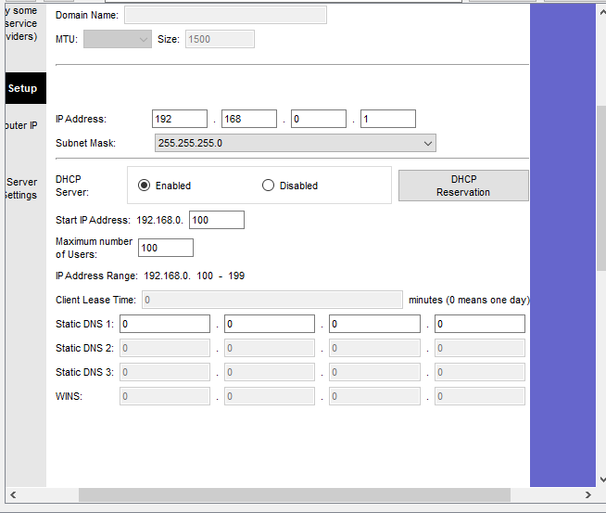

Checking If our DHCP is working properly or not.

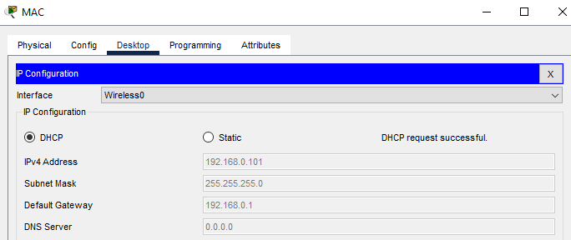

**Updating Wireless Security.**

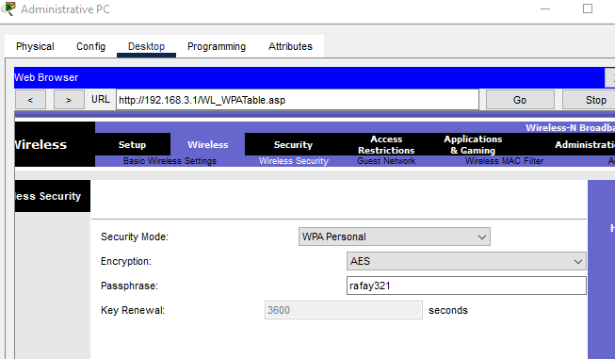

Doing so results in disconnection of our wireless connected devices.

Now we have to connect them back to our network .

By Following these steps.

Accessing PC wireless

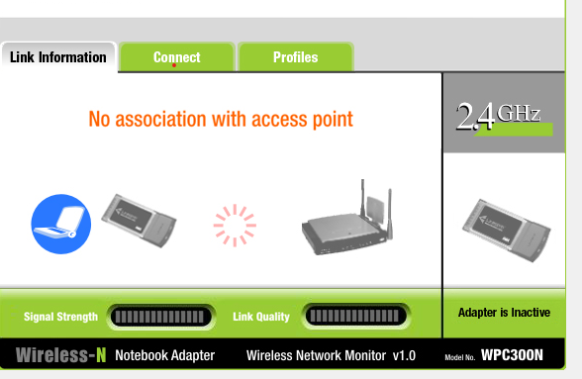

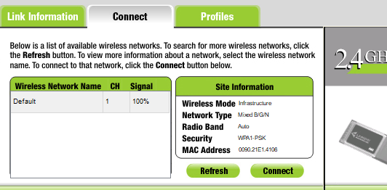

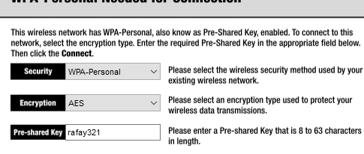

Laptops are now connected back to the network.

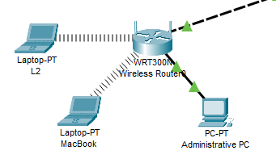

**Router0 IP CONFIG.**

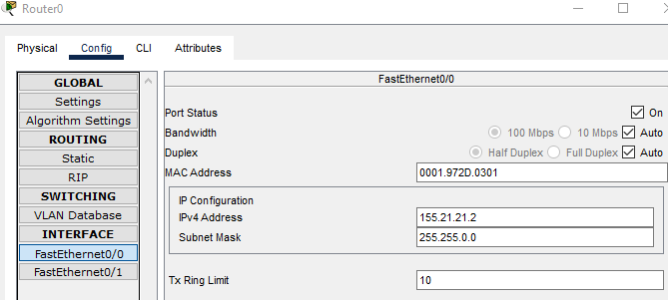

**Wireless Router Internet Port Config.**

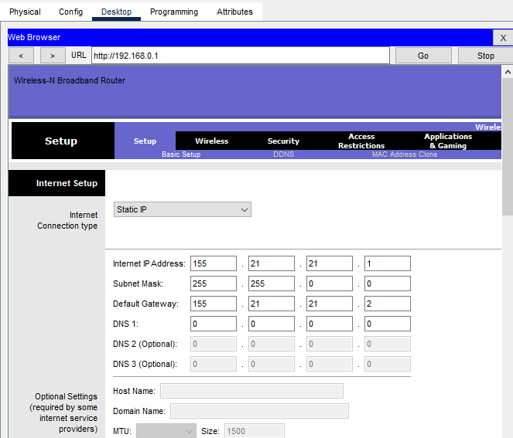

**Static Route Setting using ISP Router CLI**

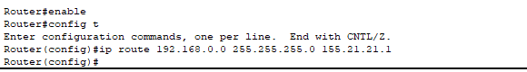

**Web Server CONFIG.**

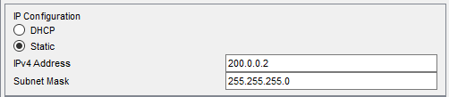

**Finally accessing our Website using one of the PC/Laptop.**

